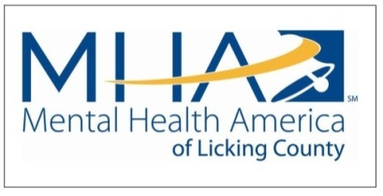
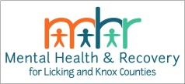
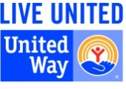
65 Messimer Drive
Newark, OH 43055
(740) 522-1341
www.mhalc.org

Become a Member or Renew Your Membership:
To join or renew your MHALC membership, please complete the information and payment form below.
MEMBER INFORMATION
Title:
Name
Company or Organization
Email
Phone
Address
Address (Line 2)
City, State, Zip
Billing Address (if different):
City, State, Zip

LEVELS OF MEMBERSHIP
New Membership____ Renewal____
(√) check one | Amount | Type
 | $, 1000 | Major Benefactor**
 | $500 – 999 | Patron**
 | $250 – 499 | Bell Ringer**
 | $135 – 249 | Professional
 | $25 | Basic Annual
 | Amount______ | Other Donation
** Entitles business to a mental health training program for employees. (Please call MHALC at 740.522.1341 to schedule a program)
Check payments should be mailed to Mental Health America, 65 Messimer Drive, Newark, OH 43055.
Payment Method
Monthly or 1 Time Gift?? | ___One Time ___Monthly $_______per month ____Mo. Date of withdrawal
Total Donation |  | Credit Card Type
Name on Credit Card
Credit Card Number
CVV Number
(3 digits on back of card)
Expiration Date | Month______ Year_______
Signature
Credit Card Authorization Agreement
By completing and submitting this form, I hereby authorize Mental Health America of Licking County (MHALC) to initiate automatic donations from the credit card provided on the recurring schedule I have specified. The recurring donation will continue without any additional involvement from the card holder until MHALC is informed otherwise and receives change confirmation by mail or telephone.

Monthly Donation Authorizing Signature: _______________________________________________________

